# Make a folder shape outline

Create a rectangle with slightly rounded edges (400 x 250 – Golden Ratio is 1.6)

Set fill to No Fill, Stroke paint to a suitable color, Stroke Style Round Join and Round Cap, size 10

Rotate the rectangle to the left at a slight angle

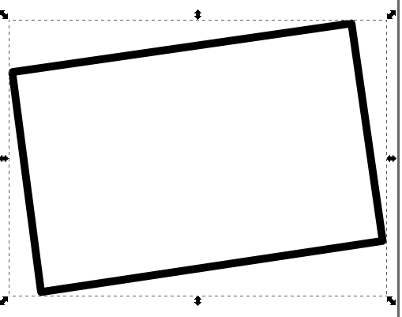

Path -> Object To Path (Shift-Ctrl-C)

Choose Edit Paths By Nodes (F2) from the left side toolbox

For each bottom node: Double Click near the node to add a new node, then slide the added node to overlay the orig. Then drag it up and right to make the folded side. Resize if needed to fit page

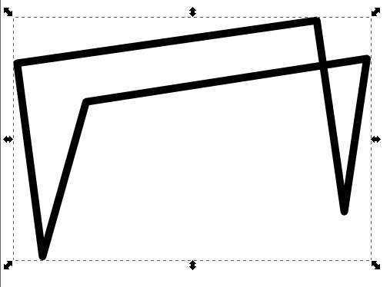

Remove the overlap line as follows: Create 2 new nodes on the line segment to delete by double clicking the line (make sure you are still using the Edit Paths By Nodes tool) at the endpoints of the to-be-deleted segment. Highlight both new nodes using the Shift key then choose the ‘Delete Segment between two non-endpoint nodes’ button from the toolbar at the top (Sixth button from left)

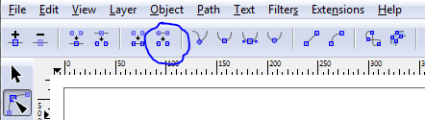

Now draw a line at the bottom to complete the folder shape. Use the Pen Tool on the left  and set the Shape at the top to None and the Mode to ‘Create a sequence of straight line segments’. 

Set Fill and Stroke to match the rest of the folder.

Path -> Object To Path (Shift-Ctrl-C), then move the endnodes so it completes the folder seamlessly.

Should now look like this:

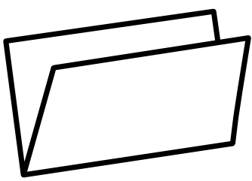

Make the tab on the top by making a rectangle the size of the tab nub, setting the fill and stroke to match everything else. Rotate it to match the angle of the original rectangle, and place it appropriately.

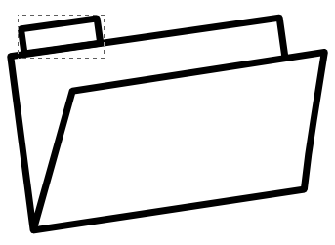

Path -> Object To Path (Shift-Ctrl-C)

Choose Edit Paths By Nodes (F2) from the left side toolbox

Double click on each of the bottom nodes in the tab shape to create new nodes. Then select both nodes using the Shift key and then choose the ‘Delete Segment between two non-endpoint nodes’ button from the toolbar at the top (You can temporarily move the tab shape off the folder to verify the segment got deleted, then move it back when done).

Highlight the original folder rectangle, and use the Edit Paths By Nodes tool and double-click to add nodes where the new tab shape meets the larger folder. Select both nodes using the Shift key and then choose the ‘Delete Segment between two non-endpoint nodes’ button from the toolbar at the top.

The last step is Edit -> Select All (CTRL-A) and then Path -> Combine (CTRL-K) to make al the paths one unified object. At his point you can set the Stroke paint color via Fill and Stroke to whatever color you want. The end result will look something like this:

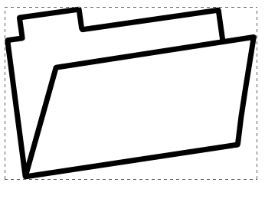

# Make a neon object

Start with an outline shape. A folder. For example.

Set the stroke width on the object to a decent width, say 10-16. For this example, I set fill to No Fill, Stroke paint to a suitable color, Stroke Style Round Join and Round Cap, size 10.

Right click on the object to Duplicate (CTRL-D) twice, so you have 3 copies. Move the top 2 out of the way to work with each individually. The top will be the highlight, the middle will be the tube and the bottom will be the blurred background.

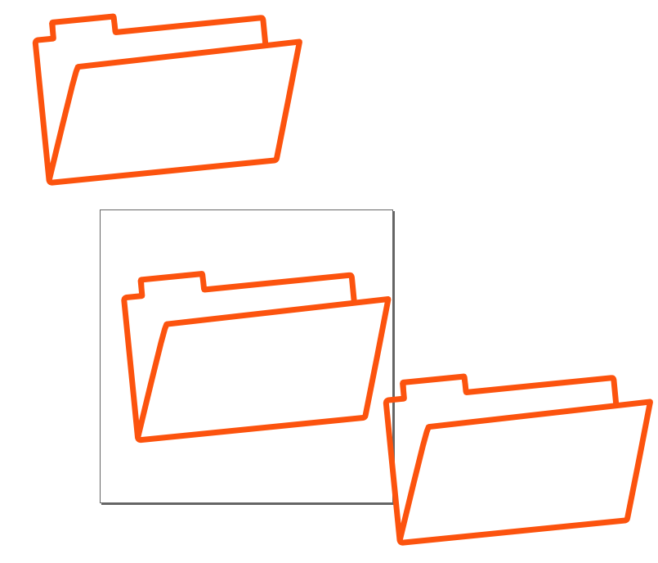

Select the top one. Make the stroke width 3, and make the color white. It will seem to disappear, but don’t panic, it’s still there. Make this the top layer by Object -> Raise to top (Home). You can also use (Page Up).

Select the bottom one. Set the blur t 4%, and then click on it to select it again, and press CTRL-D (Duplicate) to make it less faint. Select both of the blurred overlaying bottom ones and send them to the back layer via Object -> Lower to Bottom (End). You can also use (Page Down). One way to select both of them is to move one, then select the bottom one and lower it as well..

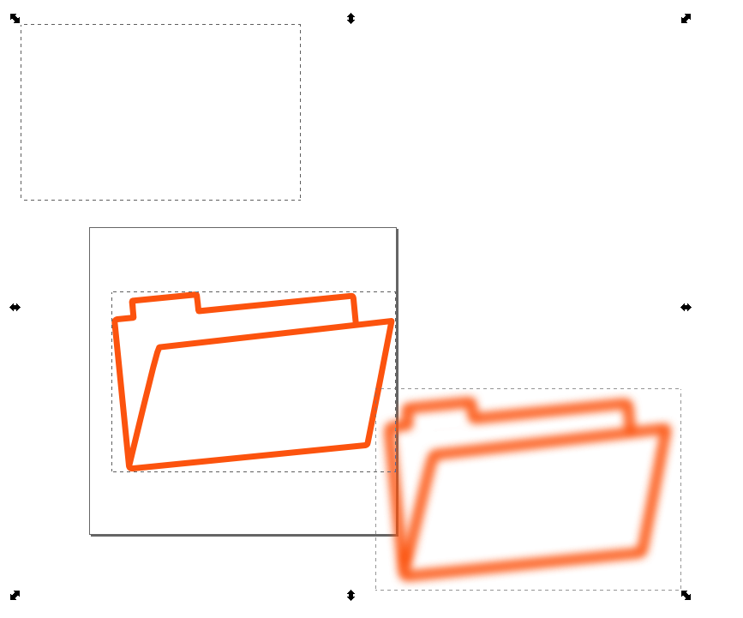

Now align them all by Edit-Select All (CTRL-A), then Object -> Align and Distribute (SHIFT-CTRL-A). This brings up the Align and Distribute dialog. Select Center on vertical Axis, and Center on horizontal axis to align all the images.

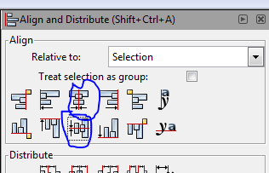

You should see something like this:

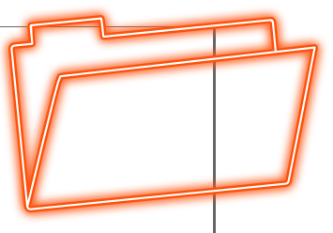

Now zoom in and select the white image, and blur it at 1.5% on the Fill and Stroke dialog to make it look more realistic.

Now,to center the completed image, combine the paths by selecting them all (CTRL-A) and then moving to wherever you want. You can keep it transparent if it will be displayed on a dark background, or you can draw a rectangle with black fill, and move that to the bottom layer.